**Topic 3. Digital ecosystems and traditional business transformation**

**The ecosystem of the digital economy**is a partnership of organizations that ensures the constant interaction of their technological platforms, applied Internet services, analytical systems, information systems of state authorities of the Republic of Kazakhstan, organizations and citizens.

There is an undeniable trend towards digitalization of all activities. In a sense, it can be considered as a trend continuation:

**technologization → mechanization → conveyorization → digitalization**

Most experts put a sign of identity between digitalization / digital transformation / digitalization / Industry 4.0 and the digital economy, thereby reducing all understanding of the digital economy to the sum of information and communication technologies and completely losing the entire economic component of the revolution that is taking place around us.

Without a doubt, digitalization is an absolutely necessary component of the digital economy, its infrastructural and instrumental base. But the digital economy, since we want to talk about the economy, is a more complex concept.

**Prospects for the development of the digital economy.**

There are many definitions of the digital economy. Most of them focus on some of its manifestations, leaving out the big picture. One of the most common definitions, accepted around the world, is formulated as follows:

***The digital economy***enables and conducts the trade of goods and services through electronic commerce on the internet. The digital economy is based on three pillars: supporting infrastructure (hardware, software, telecoms, networks, etc.), e-business (processes that an organization conducts over computer –mediated networks) and e-commerce (transfer of goods online).

***The digital economy***allows and implements trade in goods and services using electronic commerce via the Internet. The digital economy includes three components: infrastructure (devices, software, telecommunications, etc.), e-business (digital processes, in organizations) and e-commerce (selling goods online).

This definition, like most other definitions, does not disclose the essence of the changes taking place, does not reflect their relationship with technologies, does not describe economic influences, such as changes in user behavior, changes in relations between consumers and producers, changes in competition, changes in labor productivity, changes in the structure of added cost and many other aspects.

The official definition was given in the information society development strategy:

***The digital economy***is an activity in which the key factors of production are data presented in digital form, and their processing and use in large volumes, including immediately at the time of their formation, allows, in comparison with traditional forms of management, to significantly increase efficiency, quality and productivity in various types of production, technologies, equipment, storage, sale, delivery and consumption of goods and services.

This definition is conditionally operational, but not completely exhaustive. Since the definition must be either correct or official, now we will focus on the official version, refraining from proposing our own wording. However, the purpose of this article is to dive into the heart of the matter. And for this we will do three exercises, each of which should reveal the depth and breadth of the topic under study. First, we will look at the digital economy from the point of view of the technologies that underlie it and determine the direction and quality of the transformations taking place. Secondly, we will look at the digital economy from the point of view of the set of competencies required for its development and effective existence in the new environment. And thirdly, we will look at a number of examples that reveal the innovations brought in in the field of economic interactions and business schemes.

A huge variety of modern information and communication technologies constitute the infrastructural toolkit of the digital economy. The digitalization of economic activity (the processes of creation, distribution, exchange, consumption and utilization of goods and services) bears fruit for both large and small companies, the state and even individuals. The active adoption of digital tools (digital transformation or digitalization ) has been taking place in all industries around the world for over twenty years. But if earlier this happened spontaneously and uncontrollably, now large companies and states have realized the need for a structured approach. The development and implementation of digitalization strategies today is the priority of most large companies, regardless of industry, business specifics or legislative regulation.

Information and communication technologies as a class includes a huge number of tools and developments: from various state sensors to theories substantiating the areas of optimal application of a particular software architecture. When talking about the digital economy, there are several defining technologies that need to be addressed: clouds, distributed computing, big data, and the Internet of Things. The second most important group of technologies includes blockchain, digital twins, augmented reality, additive manufacturing, robots and cognitive technologies. And let's pay special attention to the fact that technologies such as centralized storage and data processing centers, broadband Internet access and others, which many companies and experts focus on, have very little impact on the development of the digital economy.

The most important and defining technology is the digital platform. We will talk about its importance from the point of view of economics, business and ideology later, but now we will emphasize the fact that the platform as a software product accumulates all the other necessary technologies, providing a huge number of users with access to information, high-quality services for planning, analytics and, most importantly, access to the market (to customers, to manufacturers, to service organizations, and so on).

In the past few years, there has been another qualitative leap in the development of information and communication technologies, associated with four circumstances:

• digital technologies are constantly expanding the scope of their own application;

• the cost of implementing and operating the appropriate tools is constantly falling;

• the degree of digitalization of economic activity is constantly increasing (including due to the influence of the first two factors);

• the availability and prevalence of digital devices (computers, telephones, smart devices and machines connected to the Internet of Things) is constantly growing.

The complex of these circumstances led to the formation of qualitatively new conditions in which new business models based on the development of digital ecosystems supported by digital platforms become economically meaningful.

Digital platforms, being the quintessence of the digital economy toolkit, integrate a huge amount of the latest technologies and provide users (both manufacturers, consumers and intermediaries) with access to the best digital tools and a free competitive market, which leads to a qualitative change in the rules of the game in the corresponding segment. In other words, we can continue the trend line

**technologization → mechanization → conveyorization → digitalization → platformization**

***a digital platform***is a system of algorithmized relationships between a significant number of market participants, united by a single information environment, leading to a decrease in transaction costs through the use of a digital technology package and changes in the division of labor.

According to the degree of development of the provided functionality, seven main classes of digital platforms can be distinguished (Table 1).

Table 1. Classification of digital platforms according to the degree of functional development

|  |  |  |  |
| --- | --- | --- | --- |
| **Platform class** | **Additional functionality** | **examples** | |
| **1. Technological** | **Provide access to IT resources and technologies** | **Alibaba Cloud**  **Computing**  **Amazon AWS**  **Microsoft Azure** | |
| **2. Functional** | **Provide access to specialized tools** | **Exact farming**  **SAP**  **1C**  **Bitrix** | |
| **3. Infrastructure** | **Provide access to digital infrastructure** | **Iqdq.ru**  **Yandex maps** | |
| **4. Corporate** | **Optimize management processes** | **Boeing suppliers portal**  **Government purchases**  **X5 GoCargo** | |
| **5. Information** | **Provide informational access to the market** | Avito  **Yandex- Market**  **price . ru** | |
| **6. Marketplaces** | **Provide market access by enabling interactions between parties** | **AliExpress**  **Tmall**  **Amazon**  **e-bay** |  |
| **7. Industry** | **Optimize participant interactions** | **Smartcat**  **Cainiao** |  |

For each developed digital platform (starting from the fifth grade), five user groups can be distinguished (Figure 1):

* platform operator - maintains the platform's performance, manages the process of functional development;
* suppliers - provide goods and services advertised and / or sold through the platform;
* consumers - buyers of goods and services;
* service providers - create functional modules that are of value to suppliers and / or consumers;
* regulator - a body that monitors compliance with the legal framework.



Figure 1. User groups (participants) of an advanced digital platform

Each developed digital platform is built around some kind of massive economic process , providing interaction between consumers and suppliers:

• Uber - interaction between taxi drivers and taxi users;

• CarSharing - interaction between car owners and renters;

• Airbnb - interaction between landlords and tenants of residential premises;

• and so on.

It should be remembered, however, that the digital platform must bring added value to all participants. Uber users get a faster, safer and cheaper taxi service with guaranteed quality. Drivers receive a flow of orders based on their current location, allowing taxi utilization to be increased by up to 90%. By listing their goods on AliExpress or e- Bay , the manufacturer gets the opportunity to demonstrate it to billions of buyers around the world without building their own logistics system. The buyer, using these marketplace platforms, can choose the best product in terms of price and quality from all possible.

One of the most important properties of economic processes on the platform, which distinguishes them from the usual forms of interaction, is algorithmization . The platform limits the variability of user actions with its current functionality: for example, a marketplace platform can provide purchase functionality, but not support an installment or credit purchase. The functionality of developed industry platforms can be very flexible and diverse, provide for many forms of interaction: for example, a smart contract with a large number of parameters. But in any case, the spectrum of possible interactions is strictly defined.

Also, the platform naturally captures and remembers all transactions. Economic processes implemented on the basis of platforms are transparent and amenable to analysis. With significant platformization , the entire economy of the country is naturally digitized and becomes transparent: a multi-level digital model of the state's economy is formed, detailed down to each individual transaction.

**Features of the development of the digital economy in Kazakhstan.**

Digital Valley of Kazakhstan. The agricultural digital platform “Digital Kazakhstan” is functioning in the Republic of Kazakhstan. It has a fairly developed functionality and belongs to the class of industry. In addition to significant optimization of existing business processes and economic interactions (between participants in the multilateral market and the state), it makes possible a number of new processes. Now we will consider only one of the many (Figure 3).

One of the winegrowers has developed a highly effective integrated technology for growing grapes using automated monitoring of the state of soil, air, water, control of the irrigation system, fertilizers, etc. Significant funds and time have been invested in the development of the technology , which cannot be recouped within the framework of their own economy. This technology has been hosted on an agricultural digital platform. Anyone can implement this technology in their own household using the appropriate cloud service. The use of technology significantly improves the quality of the grapes and increases the yield. For anyone who expresses a desire to use the technology, the platform charges a small fee, which is distributed between the platform itself and the owner of the technology.

Please note that this scheme, firstly, is impossible without a digital platform, because:

• without a platform, it is impossible to understand who and to what extent uses this technology,

• replication of technology without a platform is difficult,

• without a platform, it is impossible to monitor compliance with the process;

and, secondly, this scheme is beneficial to all participants in the process:

• the developer gets the opportunity to monetize his developments,

• growers receive guaranteed demand,

• the winery receives the predicted volume of quality-assured raw materials.



Figure 3. Economic interactions within the Digital Kazakhstan agricultural digital platform

1. An innovative technology for growing grapes is placed on the platform

2. Private farms can introduce new technology

3. Management and control of the technological process are carried out through the platform

4. The winery can control compliance with the technology

5. The plant accepts products grown using new technology

6. The technology developer receives a fee from each farm that uses his technology

**Indicators of digitalization of the economy : main indicators (Digital Economy and Society Index (DESI), Networked Readiness Index (NRI), Digital Evolution Index (DEI), IMD World Digital Competitiveness (WDC), etc. ).**

One of the most notable phenomena of the last decade is the transition to the next stage of globalization - digital transformation, which consists in a fundamental change in the structure of the world economy, its global virtualization due to the emergence of new forms of cross-border movement of virtual goods, capital, and labor. In this regard, measuring the level of development of the digital economy of a particular country and the degree of its digital globalization becomes a major task for researchers.

The level of development of the digital economy and the country's rating are measured on the basis of various composite indices that integrate individual sub-indices that are responsible for the digital transformation of individual sectors of the economy and society. The most famous ratings are based on the following indices:

- Index of development of information and communication technologies (ICT Development Index - IDI);

- Index of digital economy and society ( Digital Economy and Society Index - DESI);

- Index of world digital competitiveness (IMD World Digital Competiveness Index - WDCI);

- Index of digital evolution (Digital Evolution Index - DEI);

- Index of digitalization of the economy of the Boston Consulting Group (e-Intensity);

- Index of network readiness (Networked Readiness Index - NRI);

- The index of the development of e- government (The UN Global E-Government Development Index - EGDI);

- Index of electronic participation (E-Participation Index - EPART);

- The index of global connectivity (Global Connectivity Index - GCI, Huawei );

- Global Index Innovation (The Global Innovation Index - GII) .

The results of these ratings for individual EAEU and EU countries are summarized in Table 1. The differences in the ratings are in the selection of initial indicators (characteristics of the level of use of the digital economy achievements in the country) and their grouping into sub-indices .

An analysis of the indicators of existing international indices and ratings, the methodology for forming micro - indices , sub-indices and a composite index from them , pros and cons, commonality and differences will make it possible to use them in the future to form new author's indices reflecting the level of countries' readiness for the digital economy and the degree of digital globalization.

*Digital transformation is the use of modern technology to dramatically increase the productivity* and value of enterprises .

Digital transformation is now a popular topic of discussion among technical professionals, but in fact it has been talked about for several decades. For a long time, digital transformation has meant digitalizing or storing traditional forms of data in digital format. This is also one of the areas of digital transformation, but in the modern world this concept is much broader than digitalization.

When enterprises realized the full potential of using digitized data, they began to develop processes for this purpose. From that moment on, digital technologies began to develop rapidly, and the ability to quickly implement them directly determines the competitiveness of enterprises.

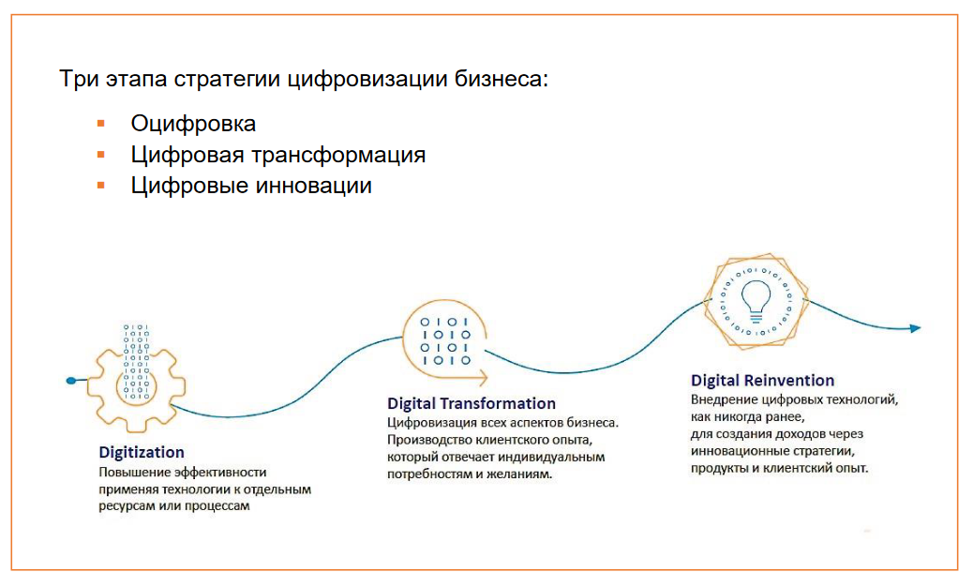

We understand digitalization as the fullest possible disclosure of the potential of digital technologies through their use in all aspects of business - processes, products and services, approaches to decision-making. It is important to emphasize that the mere availability of technology as such will never be sufficient for digitalization . In order for the digitalization process to be complete, clearly formulated business objectives and data are needed (Figure 1).

Imagine a filing cabinet in a regular library. You come for a book, the librarian manually searches for a book card in the catalog, and then goes after it to the desired rack. If the catalog is digitized, the librarian will quickly find the card on the computer. But this will only affect one process, so here we are talking about automation.

Or you can digitize all the books in the library and create an application so that people can read through it. You can also study the behavioral habits of the users of the application to make it more convenient. Tracking and analyzing which sites potential consumers visit, launching viral ads, etc. is already a digital transformation.

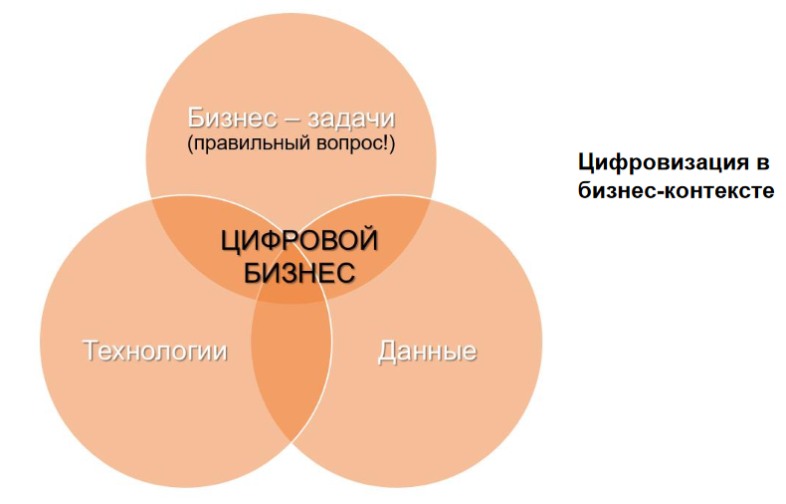

When people talk about digital innovation, they often mean breakthrough ideas and products, by introducing and presenting which, a company can become the “new Google ”. But innovation is just one of the possible vectors of the digitalization effect . In reality, for sustainable development and the formation of protection of traditional companies from possible attacks by new players, digitalization of the business core often becomes the most significant, both in terms of optimizing business processes and in terms of finding additional sources of growth.

Can unrealized digital transformation be a threat to established businesses? The answer is yes, it can. Imagine a competitor who, using artificial intelligence, performs all operations much faster, more efficiently, while significantly reducing the cost of its products and increasing sales.

Nowadays, more and more often, the question is literally posed like this: digitalize or die. If the issue of a company's readiness and desire for a successful digital transformation is almost a matter of life and death, then it is imperative to learn how to identify and manage the components of a successful digital transformation.

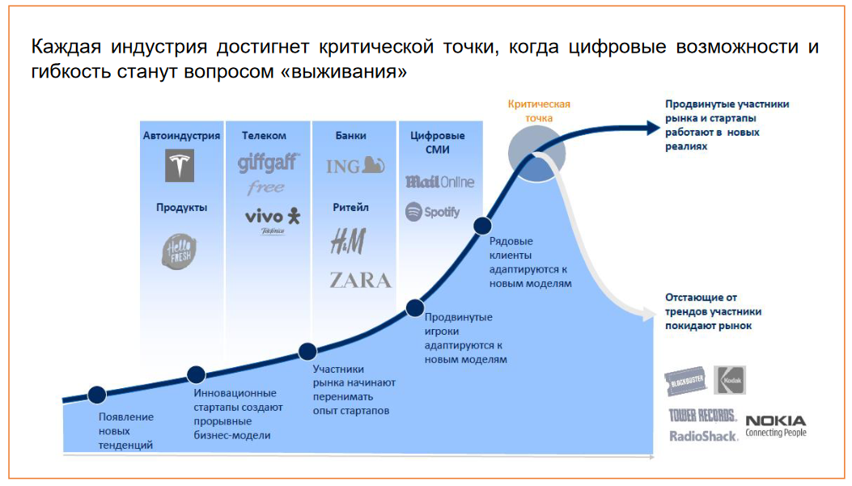

**Internet of things**

The Internet of Things is a network of connected devices, a set of sensors for collecting information and subsequent processing, which exchange data and can be controlled remotely. The information received is processed using big data analysis tools to improve the accuracy and quality of decisions.

**Big data analytics and predictive analytics**

The speed and quality of big data processing affects the efficiency and productivity of companies. Predictive analytics solutions are used to analyze large amounts of data and generate predictions. This technology includes functions of statistical modeling, analysis of historical indicators and planning of results.

**Artificial intelligence**

Artificial intelligence technologies are designed to perform complex tasks with computers and optimize the use of human resources.

**Digital twin**

A digital entity that reflects a real object, process or system. Digital twins can also be linked together to create twins to larger systems such as a power plant or city. Today, the focus is on digital twins in the loT , which can improve enterprise decision making by providing health data and efficiency gains.

**Peripheral Computing**

The technology of peripheral computing consists in the location of information collection and analysis centers near the data source (digital devices) to reduce the level of information transmission latency. The development of this technology with the development of IoT solutions - the number of devices and received data increases, with the help of edge computing technology, it is possible to analyze information received from devices more efficiently and in a structured manner.

**A virtual reality**

Virtual reality and augmented reality technologies are technologies for projection or augmentation of reality using technical means. This allows you to reduce the cost of performing processes through the design and simulation of work steps.

**Blockchain**

A blockchain is a database that stores information about the actions of all its participants in the form of a "block chain". A feature of such a database is that each user confirms the truthfulness of the information that other users enter, thereby reducing the risks of fraud or misuse of information.

**Smart space**

Smart space is a physical or digital environment in which people and technological systems interact with each other. The largest examples of smart spaces are smart cities, business centers, residential communities, etc.

**Quantum and computing**

A type of non-classical computation based on the quantum state of subatomic particles that represent information in the form of elements designated as quantum bits or "qubits ." Quantum computers are an exponentially scalable computational model.